Orbital steroid injection versus orbital radiation therapy in treatment of active thyroid eye disease
Mobile:
E-mail:

ABSTRACT
Background: Thyroid eye disease is an autoimmune disorder of the retrobulbar tissue. Various treatment modalities are available as peribulbar steroid injection and orbital radiotherapy. Orbital decompression is needed when no improvement after conservative treatment is observed in the inactive phase of the disease.
Aim and objectives: To compare the efficacy and safety of orbital steroid injection versus orbital radiotherapy in treating patients with active thyroid eye disease by clinical activity score system.
Subjects and methods: This is a prospective interventional non-randomized comparative study that was conducted on 30 orbits in patients with active thyroid eye disease attending the outpatient ophthalmology clinic of Benha University and Research insititute of ophthalmology in Giza in the period from march 2021 till May 2023. Radiation therapy was conducted at El-Salam Oncology Center in El-Salam city.
Results:There were significant improvement of proptsosis,CAS and upper lid retraction in both groups,There was significant improvement of VA and motility in radiotherapy group. There was no significant improvement of extraocular muscle thickeness in both groups.
Conclusion:Both peribulbar steroid injection and radiation therapy are effective procedures for the management of active thyroid eyed disease.Radiation therapy resulted in more significant improvement of both visual acuity and proptosis than peribulbar steroid injection. Both groups showed significant improvement of CAS and upper lid retraction with more improvement in the radiotherapy group.Group II showed significant improvement of the degree of motility restriction by Hess screen mainly in adduction and elevation.Both groups showed minimal effect regarding extraocular muscles thickeness after treatment.
Keywords: Orbital steroid, orbital radiation, active thyroid eye disease

INTRODUCTION
Thyroid eye disease or Graves’ orbitopathy is an autoimmune disorder of the retrobulbar tissue most commonly associated with Graves’ hyperthyroidism (Graves’ disease); however, patients may be hypothyroid or euthyroid. Thyroid eye disease may precede or follow endocrine manifestations but they tend to present within 18 months of each other in 80 % of patients.Thyroid eye disease and Graves’ hyperthyroidism can occur at any age but women in their third to fifth decade of life are more commonly affected⁽¹⁾.
Graves’ ophthalmopathy (GO) can be debilitating as it may lead to diplopia, ocular hypertension, optic nerve damage and glaucoma. Even mild TED could affect the patient's quality of life. While TED is more common in younger females, studies have posited that males and advancing age are at a higher risk of severe disease. TED is also common among those with unstable thyroid function, active or passive smoking, acute stress and prior radioablative iodine therapy have been associated with new onset or worsening of TED ⁽²⁾.
Accurate evaluation of the clinical features of TED is essential for early diagnosis, identification of high risk disease, planning medical and surgical intervention, and assessing response to therapy.
Evaluation of the activity and severity of TED is based on a number of clinical features: appearance and exposure, periorbital tissue inflammation and congestion, restricted ocular motility and strabismus, and dysthyroid optic neuropathy.Several classification systems have been devised to grade severity of these clinical manifestations. These include the NO SPECS Classification (No physical signs or symptoms, Only signs, Soft tissue involvement, Proptosis, Extraocular muscle signs, Corneal involvement, and Sight loss), the European Group on Graves Orbitopathy severity scale, the Clinical Activity Score of Mourits, and the VISA Classification⁽³⁾.
Patients with Graves’ ophthalmopathy should be managed by a coordinated team of primary care physicians, endocrinologists, and ophthalmologists with specialty experience in managing TED. This typically involves a neuro-ophthalmologist, an orbital surgeon, and a strabismus surgeon⁽⁴⁾.
Radiotherapy may intervene in the disease process by inducing apoptosis or disrupting the functions of B and T lymphocytes, macrophages or orbital fibroblasts. ⁽⁵⁾.
Other method of trearment is systemic corticosteroids but due to resistance to and dependence on steroids, or complications related to systemic use of steroids including gastric ulcer ,weight gain, hyperglycemia and systemic hypertension, some authors have suggested local injection of steroids. Steroids may be injected locally within the orbital space and have been shown to entail lower complications than systemic steroids⁽⁶⁾.
This work aimed to compare the efficacy and safety of orbital steroid injection versus orbital radiotherapy in treating patients with active thyroid eye disease by clinical activity scorec system.

PATIENTS AND METHODS
This is a prospective interventional non-randomized comparative study that was conducted on 30 orbits in patients with active thyroid eye disease attending the outpatient ophthalmology clinic of Benha University and Research insititute of ophthalmology in Giza in the period from march 2021 till May 2023.
The following examinations were performed in all eyes enrolled in the study, at baseline conditions:Thyroid function test (Free T3, Free T4, TSH and Antithyroglobulin) and grading of the activity the disease according to the EUGOGO protocol for assessment of Graves's orbitopathy:
Clinical activity score (CAS) system as follow: Spontaneous orbital pain, Gaze evoked orbital pain, Eyelid swelling, Eyelid Erythema, Conjunctival redness, Chemosis, inflammation of caruncle or plica. Patients were assessed after follow up and scored out of 10 by including items 8-10, increse of ≥ 2mm in proptosis, Decrease in uniocular ocular excrusion in any one direction of ≥ 8° and Decrease of acuity equivalent to 1 snellen line (Figure 1).

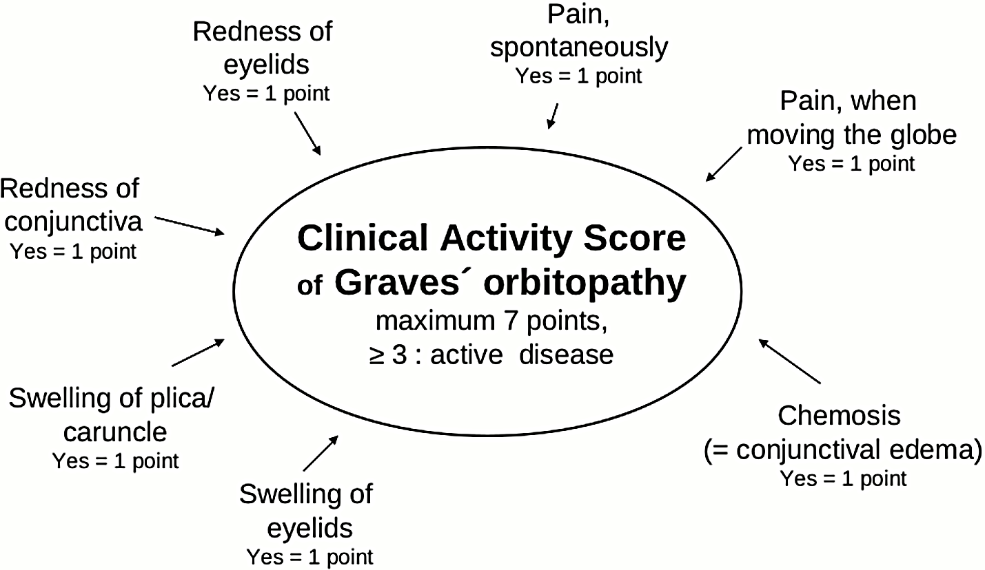
Figure (1) Algorithm for detection of clinical activity score ⁽⁷⁾.

All patients who had active thyroid eye disease (CAS ≥ 3) were included and divided into 2 groups:
Group I : They were treated by single peribulbar Triamcinolone Acetonide injection (40 mg /ml). We further subdivided the first group into 2 subgroups, each of them includes ten orbits:
The first subgroup ( subgroup A) includes 6 patients ( 4 of them had bilateral disease and two of them had unilateral disease) and they didn’t receive previous systemic steroid treatment.
The second subgroup (subgroup B) includes 8 patients (two of them had bilateral disease) and they have received previous systemic steroid (oral prednisolone 1mg/kg) before the local treatment.
Group II: received IMRT (intensity modulated orbital radiation therapy).15 patients were included but only data from 10 orbits are included (4 patients with bilateral disease and 2 patients with unilateral disease).The other cases didn’t complete the study (2 cases didn’t complete the radiation sessions and 3 cases didn’t complete the follow up visits) .
Inclusion criteria: Active TAO: A patient is considered active if clinical activity score≥ 3. Moderate to severe TAO: Patients should have two or more of the following features:
- Lid retraction (≥2mm).
- Moderate or severe soft tissue involvement.
- Exophthalmos ≥3mm (above the normal range for age).
- Constant or inconstant diplopia.
- Age 18-60 years.
- Duration of TAO <2 years.
Exclusion criteria: Patients with diabetic eye diseases, or diabetic patients without good glucose control were not treated with radiation therapy.Patients with local infections in the radiation area.Patients with previous orbital surgery,trauma or had received other local orbital therapy.
Written Informed consent were obtained from each subject enrolled in the study.
Methodology:
Group I: These patients were treated by single peribulbar triamcinolone acetonide injection (40 mg/ml).A 27 G half inch disposable needle was introduced into the infero-lateral orbital quadrant at the junction of lateral third and medial 2/3 of the lower eyelid.The assigned dose of the drug was injected slowly then the needle was withdrawn and a gauze was applied to compress the eye and the injection site for 1 minute.
Group II:These patients were treated with retro-orbital irradiation using linear accelerator based intensity modulated radiation therapy (IMRT) technique (ELEKTA Synergy Platform). Radiotherapy dose was 20 Gy in 10 fractions within two to three weeks (Figure 2).

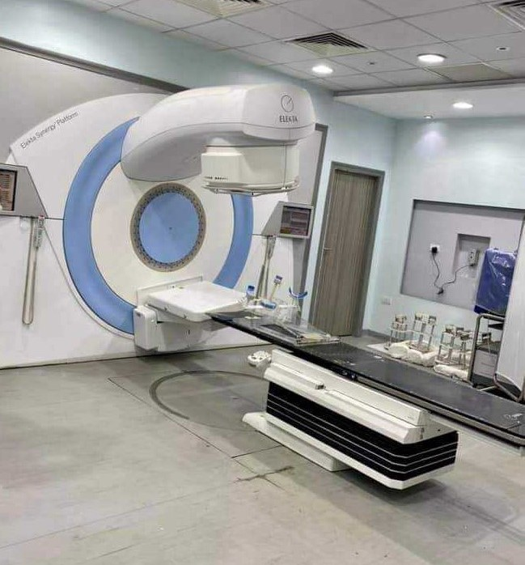
Figure (2) ELEKTA Synergy Platform linear accelerator radiotherapy device.
Statistical methods
Data management and statistical analysis were done using SPSS version 28 (IBM, Armonk, New York, United States). Quantitative data were assessed for normality using the Shapiro-Wilk test and direct data visualization methods. According to normality, quantitative data were summarized as means and standard deviations or medians and ranges. Categorical data were summarized as numbers and percentages. Quantitative data were compared between the studied groups using the independent t-test or Mann-Whitney U test for normally and non-normally distributed quantitative variables, respectively. Categorical data were compared using the Chi-square test. All statistical tests were two-sided. P values less than 0.05 were considered significant.

RESULTS
several variables did not show significant differences. These include age,gender, smoking status, duration of thyroid eye disease,family history of thyroid disease and thyroid status at baseline.Thyroid status during the study was consistent (controlled) across all groups. (Table 1).
Table (1) Demographic and general characteristics of the studied groups
 |  | Group I  (n = 20) |  | Group II  (n = 10) | P-value
 |  | Subgroup A  (n = 10) | subgroup B  (n = 10)
Age (years) | Mean ±SD | 38 ±3 | 39 ±4 | 41 ±6 | 0.243
Gender
Males | n (%) | 6 (60) | 2 (20) | 7 (70) | 0.061
Females | n (%) | 4 (40) | 8 (80) | 3 (30)
Smoking | n (%) | 3 (30) | 4 (40) | 6 (60) | 0.531
Duration of thyroid disease (ms) | Mean ±SD | 11 ±1 | 10 ±3 | 11 ±1 | 0.084
Duration of thyroid eye disease (ms) | Mean ±SD | 6 ±1 | 5 ±2 | 6 ±1 | 0.314
Previous thyroid treatment
Antithyroid drugs only | n (%) | 7 (70) | 0 (0.0) | 8 (80) | <0.001*
Antithyroid drugs & oral steroid | n (%) | 0 (0) | 10 (100) | 0 (0)
Thyroidectomy | n (%) | 3 (30) | 0 (0.0) | 2 (20)
Current thyroid treatment
Antithyroid drugs only | n (%) | 10 (100.0) | 10 (100.0) | 0 (0) | <0.001*
Antithyroid drugs & oral steroid | n (%) | 0 (0) | 0 (0) | 10 (100.0)
Thyroid status at baseline
Euthyroid | n (%) | 4 (40) | 5 (50) | 2 (20) | 0.4
Hyperthyroid | n (%) | 5 (50) | 5 (50) | 8 (80)
Hypothyroid | n (%) | 1 (10) | 0 (0) | 0 (0)
Thyroid status during the study
Controlled | n (%) | 10 (100) | 10 (100) | 10 (100) | -
Family history of thyroid disease | n (%) | 3 (30) | 0 (0) | 0 (0) | 0.089
Family history of TAO | n (%) | 0 (0) | 0 (0) | 0 (0) | -
* Significant P-value at P < 0.05
Best Corrected Visual Acuity: before treatment, significant differences were observed between groups (p<0.001). subgroup B had the highest median BCVA. After treatment,subgroup B also maintained the highest median BCVA (P<0.001). Regarding percent change, significant differences were observed between groups (p=0.016), with Group II showing a notable median increase of 29.17%.Within groups,significant change was observed only in Group II (p=0.016) (Table 2)
Proptosis:before treatment, a significant difference was observed (p=0.016),with Group II having the highest mean value.After treatment,differences remained significant (p=0.016), with a reduction in values across all groups .Regarding percent change, no significant difference was observed in the percent change among groups (p=0.983).Within groups, all groups showed significant changes (Table 2).
Clinical Activity Score: before treatment, a significant difference was observed (p<0.001), with Group II having the highest median score.Additionally, after treatment, a significant difference was observed (p<0.001), with a reduction in scores across all groups).Regarding percent change, no significant difference in percent change was observed among groups (p=0.132).Within groups, significant changes were observed in all groups (Table 2, Figure 3-5).
Lid Aperture: before treatment, a significant difference was observed between groups (p=0.008), with Group II having the highest mean value. After treatment, differences remained significant (p=0.02), with a reduction in values across groups .Regarding percent change, no significant difference in percent change was observed among groups (p=0.151).Within groups, all groups showed significant changes (Table 2).
Upper Lid Retraction: before treatment, no significant differences were observed between groups (p=0.17). Also, after treatment, differences were not significant (p = 0.065). Regarding percent change, no significant difference in percent change was observed among groups (p=0.218).Within-groups, there were significant changes in all groups (Table 2).
Table (2) Other clinical characteristics in the studied groups
 |  | Group I  (n = 20) |  | Group II  (n = 10) | P-value
 |  | Subgroup A  (n = 10) | subgroup B  (n = 10)
BCVA ( decimal)
Before | Median (range) | 0.6 (0.4 - 1) | 1 (0.6 - 1) | 0.4 (0.1 - 0.9) | <0.001*
After | Median (range) | 0.6 (0.6 - 1) | 1 (0.8 - 1) | 0.5 (0.3 - 0.8) | <0.001*
Percent change | Median (range) | 0 (-25 - 50) | 0 (0 - 33.3) | 29.17 (-11.1 - 200) | 0.016*
P-value |  | 0.783 | 0.180 | 0.016*
Proptosis (mm)
Before | Mean ±SD | 19 ±3 | 22 ±4 | 24 ±3 | 0.016*
After | Mean ±SD | 18 ±2 | 20 ±3 | 22 ±3 | 0.016*
Percent change | Median (range) | -6.8 (-14.3 - 6.3) | -10.5 (-22.7 - 6.3) | -6.3 (-14.3 - 0) | 0.983
P-value |  | 0.013* | 0.024* | <0.001*
CAS
Before | Median (range) | 3 (3 - 5) | 3 (3 - 4) | 5 (4 - 5) | <0.001*
After | Median (range) | 2 (1 - 3) | 2 (1 - 2) | 3 (2 - 4) | <0.001*
Percent change | Median (range) | -58.3 (-75 - 0) | -50 (-66.7 - -33.3) | -40 (-50 - -20) | 0.132
P-value |  | 0.01* | 0.004* | 0.004*
Lid aperture (mm)
Before | Mean ±SD | 14 ±2 | 13 ±1 | 15 ±2 | 0.008*
After | Mean ±SD | 13 ±2 | 11 ±2 | 13 ±2 | 0.02*
Percent change | Median (range) | -6.7 (-33.3 - 0) | -23.1 (-33.3 - 0) | -12.5 (-26.7 - -5.9) | 0.151
P-value |  | 0.009* | <0.001* | <0.001*
Upp. lid retraction
Before | Median (range) | 3 (1 - 4) | 2 (1 - 4) | 4 (2 - 5) | 0.17
After | Median (range) | 1 (0 - 2) | 1 (0 - 1) | 1 (0 - 2) | 0.065
Percent change | Median (range) | -50 (-100 - 0) | -75 (-100 - 0) | -70.8 (-100 - 0) | 0.218
P-value |  | 0.01* | 0.011* | 0.007*
* Significant P-value at P < 0.05

Degree of motility restriction
Elevation: before treatment, no significant difference was observed between the groups (p=0.292), with subgroup B having the most restriction. After treatment, differences remained non-significant (p=0.264), with subgroup B having the most restriction .The percent change revealed no significant difference among groups (p=0.286). However, group II showed a significant within-group change (p=0.041) (Table 3).
Depression: before treatment, no significant difference was observed among the groups (p=0.356). Also, after treatment, no significant difference was observed (p=0.290).The percent change revealed no significant difference among groups (p=0.297). Group II showed a trend towards significance in within-group comparison (p=0.059) (Table 3).
Adduction: before treatment, a trend towards significant difference was observed between groups (p=0.068), with group II having the most restriction. After treatment, differences were not significant (p=0.241). The percent change showed a significant difference among groups (p=0.012), with group II showing a significant decrease (median=-41.67%). group II showed a significant within-group change (p=0.011) (Table 3).
Abduction: before treatment, no significant difference was observed between the groups (p=0.242). After treatment, differences remained non-significant (p=0.177).The percent change revealed no significant difference among groups (p=0.795). Additionally, no significant within-group changes were observed (Table 3,Figure 4-6).
Table (3) Degree of motility restriction by Hess screen in the studied groups
 |  | Group I  (n = 20) |  | Group II  (n = 10) | P-value
 |  | Subgroup A | Subgroup B
Elevation
Before | Median (range) | -1 (-7 - 0) | -6 (-11 - 0) | -1 (-25 - 0) | 0.292
After | Median (range) | 0 (-9 - 0) | -6 (-8 - 0) | -1 (-23 - 0) | 0.264
Percent change | Median (range) | 0 (-100 - 133.3) | 0 (-27.3 - 66.7) | -4 (-53.3 - 0) | 0.286
P-value |  | 0.785 | 0.276 | 0.041*
Depression
Before | Median (range) | 0 (-14 - 0) | 0 (-5 - 0) | -2 (-15 - 0) | 0.356
After | Median (range) | 0 (-13 - 0) | 0 (-8 - 0) | -2 (-10 - 0) | 0.290
Percent change | Median (range) | 0 (-40 - 0) | 0 (-100 - 60) | 0 (-33.3 - 0) | 0.297
P-value |  | 0.102 | 0.655 | 0.059
Adduction
Before | Median (range) | -1 (-7 - 0) | -2 (-4 - 0) | -4 (-16 - 0) | 0.068
After | Median (range) | -2 (-4 - 0) | -2 (-3 - 0) | -3 (-4 - 0) | 0.241
Percent change | Median (range) | 0 (-100 - 100) | 0 (-25 - 50) | -41.7 (-75 - 0) | 0.012*
P-value |  | 0.262 | 0.564 | 0.011*
Abduction
Before | Median (range) | 0 (-3 - 0) | 0 (-2 - 0) | 0 (-16 - 0) | 0.242
After | Median (range) | 0 (-1 - 0) | 0 (-3 - 0) | 0 (-11 - 0) | 0.177
Percent change | Median (range) | 0 (-66.7 - 0) | 0 (-50 - 200) | 0 (-31.3 - 133.3) | 0.795
P-value |  | 0.317 | 0.655 | 0.655
* Significant P-value at P < 0.05
Muscle thickness
Medial Rectus: Before treatment, no significant difference was observed between the groups (p=0.106).After treatment, significant differences emerged (p=0.04), with subgroup B showing a decrease in muscle thickness.The percent change, no significant difference was observed between groups (p=0.555).Within-group comparisons revealed that subgroup B showed a trend toward significance (p=0.056) (Table 4).
Lateral Rectus: before treatment, no significant differences were observed between the groups (p=0.247). After treatment, significant differences emerged (p=0.038), with subgroup B showing a decrease in muscle thickness.The percent change revealed no significant difference between groups (p=0.754).Within groups, no significant changes were observed within any group (Table 4).
Superior Rectus: before treatment, no significant difference was observed between the groups (p=0.419). After treatment, differences were not significant (p=0.166) .The percent change revealed no significant difference between groups (p=0.444).Within-group comparisons showed no significant changes within any group (Table 4).
Inferior Rectus: before treatment, no significant difference was observed between the groups (p=0.528). After treatment, differences remained non-significant (p=0.310).The percent change showed no significant difference between groups (p=0.589). Within-group comparisons demonstrated no significant changes within any group (Table 4).
Table (4) Extraocular muscle thickness in the studied groups
 |  | Group I  (n = 20) |  | Group II  (n = 10) | P-value
 |  | Subgroup A  (n = 10) | Subgroup B  (n = 10)
Medial rectus (mm)
Before | Mean ±SD | 8.1 ±1.4 | 7.5 ±1.2 | 8.7 ±0.9 | 0.106
After | Mean ±SD | 7.8 ±1.3 | 7 ±1.3 | 8.5 ±1.3 | 0.04*
Percent change | Median (range) | 0 (-12.5 – 14.3) | -10.4 (-25 - 12.5) | -5.6 (-33.3 - 25) | 0.555
P-value |  | 0.193 | 0.056 | 0.716
Lateral rectus (mm)
Before | Mean ±SD | 8.1 ±1.1 | 7.2 ±1.2 | 8 ±1.5 | 0.247
After | Mean ±SD | 8.3 ±1.3 | 6.7 ±0.5 | 8 ±2 | 0.038*
Percent change | Median (range) | 0 (-22.2 - 57.1) | 0 (-33.3 - 16.7) | 0 (-33.3 - 28.6) | 0.754
P-value |  | 0.651 | 0.299 | 0.960
Superior rectus (mm)
Before | Mean ±SD | 8 ±2.2 | 7.3 ±1.2 | 7.2 ±1.1 | 0.419
After | Mean ±SD | 7.8 ±2 | 7 ±1.2 | 6.6 ±1.1 | 0.166
Percent change | Median (range) | 0 (-30 - 50) | 0 (-28.57 - 16.7) | -12.5 (-33.33 - 33.3) | 0.444
P-value |  | 0.751 | 0.554 | 0.153
Inferior rectus (mm)
Before | Mean ±SD | 8 ±2 | 9 ±1 | 9 ±1 | 0.528
After | Mean ±SD | 7.7 ±1.5 | 8.6 ±1.4 | 8 ±1.2 | 0.310
Percent change | Median (range) | -11.81 (-25 - 18.8) | 0 (-40 - 25) | -11.11 (-37.5 - 28.6) | 0.589
P-value |  | 0.174 | 0.559 | 0.104
* Significant P-value at P < 0.05
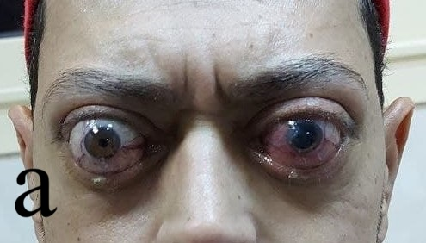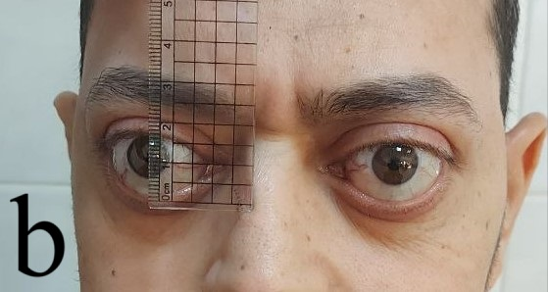
Figure (3) 37 year old male a: clinical photo at baseline , b:patient after 6 months of receiving 12 sessions of radiotherapy (20 gy) for both orbits showing improvement of chemosis, conjunctival hyperemia, upper lid rertraction and proptosis.
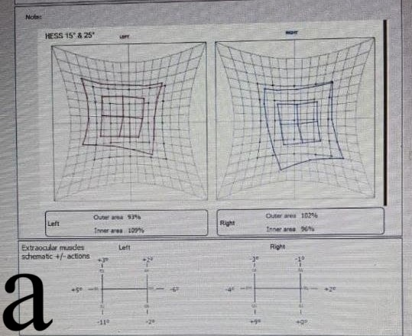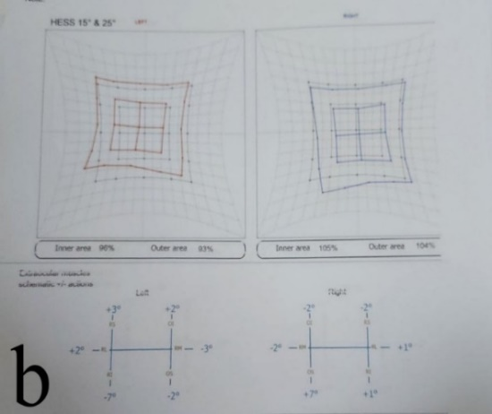
Figure (4) Hess screen of the same pateint, a at baseline and b 6 months after radiotherapy with minimal improvement.
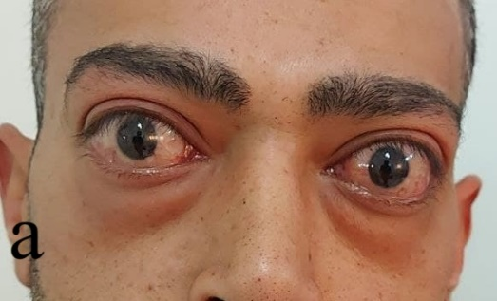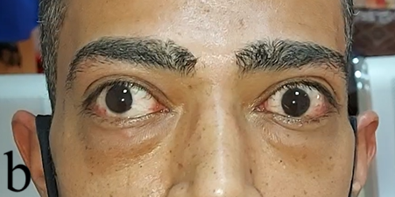
Figure (5) 38 years old male a: clinical photo at baseline, b: patient after 6 months of receiving peribulbar 40 mg triamcinolone acetonide for both orbits without previous systemic steroid showing mild improvement of lower lid edema and conjunctival hyperemia.
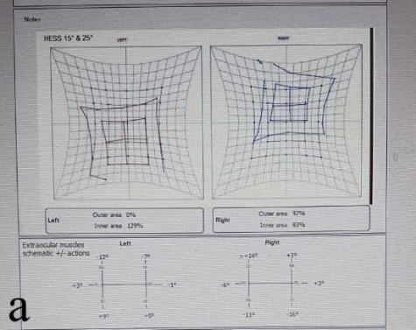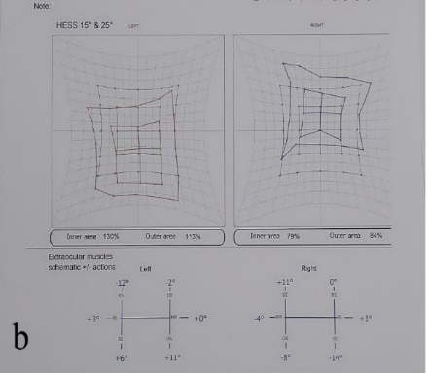
Figure (6) Hess screen a: at baseline and b: 6 months after peribulbar steroid injection with no significant improvement.
DISCUSSION
Many local complications related to periocular steroids injection are reported in many studies including globe perforation, arterial occlusion and toxic optic neuropathy,⁽⁹⁾but we didn’t encounter any of these complication. The use of ½ inch 27-gauge needle in our study allows easy passage of the drug into anterior orbit just behind the orbital septum, while reducing the risk of globe injury or intravascular injection.
The results in our study of subgroup A are comparable to those reported by Haytham et al.⁽¹⁰⁾who enrolled 18 patients and compared the efficacy of peribulbar injection of steroid in one orbit and peribulbar injection of methotrexate in the other orbit. A statistically signifcant reduction of the mean clinical activity score was detected from 5.1±0.9 at baseline to 1±1.7 at study endpoint, p-value<0.001 in the triamcinolone arm, mean proptosis also decreased from 24.2±3.06 mm at baseline to 23.2±3.3 mm at study endpoint, p-value=0.049 in the triamcinolone arm.In addition lid aperture and soft tissue signs improved signifcantly in the same arm. The BCVA remained stationary throughout the trial with minimal effect on EOM as our study. However we achieved these results after a single peribulbar injection of high dose triamcinolone 40 mg while Haytham et al, achieved these results after three periocular injections of lower dose triamcinolone (three injections of 20 mg every 3 weeks).
In another study done by Poonyathalang et al.⁽¹¹⁾ 27 eyes of 19 patients, with active TAO received retrobulbar 40 mg triamcinolone treatment for each orbit weekly (totaling 4 applications) with no previous systemic steroid treatment. Three months after treatment, most of the patients demonstrated no significant change in visual acuity and visual field. Improvement of proptosis was observed in 15 eyes and stable in 10 eyes.Seven patients had improvement of extraocular muscle function as demonstrated by Hess test. These results remained stable in the majority of patients at the 6 months follow up period. No systemic side effects were observed.
The improvement of extraocular muscle function in Poonyathalang et al.⁽¹¹⁾ study than our study and Haytham et al study may be partially explained by the differences in methodology. In our study, single injection was given while in Haytham et al study, fewer injections with lower doses were given with longer intervals between injections (three injections of 20 mg every 3 weeks) versus four injections of 40 mg every week in Poonyathalang et al study.
Furthermore, The results in the our study of subgroup B are comparable to those reported by Bagheri et al.⁽⁶⁾ study in which 31 eyes of 17 patients with active thyroid ophthalmopathy and clinical activity score (CAS) of 3 or more. All subjects had a history of previous systemic steroid use (with steroid resistance or dependence) or had developed complications related to steroids. A combination of steroids including triamcinolone acetonide 20 mg and dexamethasone 4 mg was injected in the upper and lower retroseptal orbital spaces three or four times at one-month intervals. Mean pre-injection CAS was 5.2±1.3 which was significantly improved to 1.6±1 after the fourth injection (P<0.001). Upper lid retraction also significantly improved in 100% of the affected eyes. Strabismus completely resolved in one of five affected patients and the most significant improvement was observed in supraduction. Mean improvement in exophthalmos was 1.2±1.1 mm. Visual acuity did not significantly change after the injections as our study.
The improvement of Strabismus that was noted by Bagheri et al.⁽⁶⁾ may be explained by the repeated peribulbar injections of triamcinolone acetonide 20 mg and dexamethasone 4 mg (mixed steroids) that was injected in the upper and lower retroseptal orbital spaces three or four times at one-month intervals. Unlike our study in which patients received single peribulbar injection of triamcinolone acetonide 40 mg.
Concening Group II (radiotherapy group) of our study, we have reported significant improvement in BCVA , proptosis, CAS and upper lid retraction while extraocular muscle motility shows mild significant improvement mainly in elevation and adduction. Extraocular muscle thickeness showed non-significant improvement.
The results in group II are comparable to those reported by Kim et al.⁽¹²⁾ who included 16 patients after failure to respond to IV corticosteroid therapy in the active phase. Treatment was then done using intensity-modulated radiation therapy (IMRT), Kim et al showed a dramatic reduction in EOM volume during the first year after RT in patients with Graves’ ophthalmopathy, (p<0.001 in all cases) followed by a continued slow regression after 1 year, which lasted until the last measurements at the 2-year follow-up point unlike our study in which no significant reduction of the EOMs volumes were noted. In contrast, exophthalmos length decreased slowly and steadily during the entire follow-period, without any rapid change. The mean relative reduction in exophthalmos was 3.3%, 7.7%, and 11.5% at 6, 12, and 24 months after irradiation, respectively in agreement to our study with significant improvement of proptosis after 6 months. These results suggest that the follow-up period should be longer than 1 year to show significant improvements.
In the study by Choi et al.⁽¹³⁾ 62 moderate-to-severe active GO patients treated with radiation therapy. 72.6% of cases had previously been treated with high-dose IV glucocorticoids. Low-dose oral steroids were administered to 54.8% of patients during RT. CAS improved steadily (P<0.001) as our study, while proptosis and VA improved up to 3 months (P=0.002) and (P=0.006) respectively and then remained unchanged. MRD1 were unchanged before and after RT (P=0.905) unlike our study.
Furthermore, Choi et al.⁽¹³⁾ also reported significant reduction in the volumes of the superior rectus, inferior rectus, medial rectus, lateral rectus and orbital fat after RT unlike our study as we didn’t encounter significant improvement in extraocular muscles volumes after radiation therapy.
CONCLUSION
From our study we can conclude that both peribulbar steroid injection and radiation therapy are effective procedures for the management of active thyroid eyed disease. Radiation therapy resulted in more significant improvement of both visual acuity and proptosis than peribulbar steroid injection. Both groups showed significant improvement of CAS and upper lid retraction with more improvement in the radiotherapy group. Group II showed significant improvement of the degree of motility restriction by Hess screen mainly in adduction and elevation, unlike Group I which showed no significant improvement in the degree of motility restriction in any gaze.Both groups showed minimal effect regarding extraocular muscles thickeness after treatment.

REFERENCES

1. Weiler DL. Thyroid eye disease: a review. Clin Exp Optom. 2017;100(1):20–5.
2. Chin YH, Ng CH, Lee MH, Koh JWH, Kiew J, Yang SP, et al. Prevalence of thyroid eye disease in Graves’ disease: A meta-analysis and systematic review. Clin Endocrinol (Oxf). 2020;93(4):363–74.
3. Dolman PJ. Grading severity and activity in thyroid eye disease. Ophthalmic Plast Reconstr Surg. 2018;34(4S):S34--S40.
4. Bothun ED, Scheurer RA, Harrison AR, Lee MS. Update on thyroid eye disease and management. Clin Ophthalmol. 2009;543–51.
5. Wiersinga WM. Autoimmunity in Graves’ ophthalmopathy: the result of an unfortunate marriage between TSH receptors and IGF-1 receptors? J Clin Endocrinol Metab. 2011;96(8):2386–94.
6. Bagheri A, Abbaszadeh M, Yazdani S. Intraorbital steroid injection for active thyroid ophthalmopathy. J Ophthalmic Vis Res. 2020;15(1):69.
7. Ponto KA, Kahaly GJ. Autoimmune thyrotoxicosis: diagnostic challenges. Am J Med. 2012;125(9):1.
8. Xu D, Liu Y, Xu H, Li H. Repeated triamcinolone acetonide injection in the treatment of upper-lid retraction in patients with thyroid-associated ophthalmopathy. Can J Ophthalmol. 2012;47(1):34–41.
9. Sabita P, Ajit T, Narayan SD, Kumar SA, Niranjan A. Ocular manifestations in thyroid eye disorder: a cross-sectional study from Nepal. Int J Clin Med. 2016;7(12):814–23.
10. Swaify IY, Nasr HE, El Essawy RA, Elessawy KB. Periocular methotrexate versus periocular triamcinolone injections for active thyroid-associated orbitopathy: a randomized clinical trial. Jpn J Ophthalmol. 2023;1–12.
11. Poonyathalang A, Preechawat P, Charoenkul W, Tangtrakul P, others. Retrobulbar injection of triamcinolone in thyroid associated orbitopathy. J Med Assoc Thai. 2005;88(3):345–9.
12. Kim M, Chang JH, Lee NK. Quantitative analysis of extraocular muscle volume and exophthalmos reduction after radiation therapy to treat Graves’ ophthalmopathy: A pilot study. Eur J Ophthalmol. 2021;31(2):340–5.
13. Choi JH, Lee JK. Efficacy of orbital radiotherapy in moderate-to-severe active graves’ orbitopathy including long-lasting disease: a retrospective analysis. Radiat Oncol. 2020;15(1):1–8.

